
BUY ONE GIVE ONE BIBLE STUDY GUIDE OFFER 2026

Q: WHAT IS THE 2026 BUY ONE GIVE ONE FALL BIBLE STUDY OFFER?
DATES AVAILABLE: ORDER BETWEEN AUGUST 1 – SEPTEMBER 30, 2026
When you purchase one of the four with streaming study guides, you will receive a second copy of that same exact title at no extra cost.
Q: WHAT RESOURCES ARE ELIGIBLE FOR THIS OFFER?
This offer will be for these four (with streaming) Bible Study Guides: GOD WON’T LEAVE YOU THERE, JESUS FOLLOWERS, JESUS IN ME and THE DANIEL PRAYER
Q: HOW DO I ORDER ON THE WEBSITE?
Visit our STORE. After adding the study guide of your choice your free item(s) will be AUTOMATICALLY ADDED IN CART!

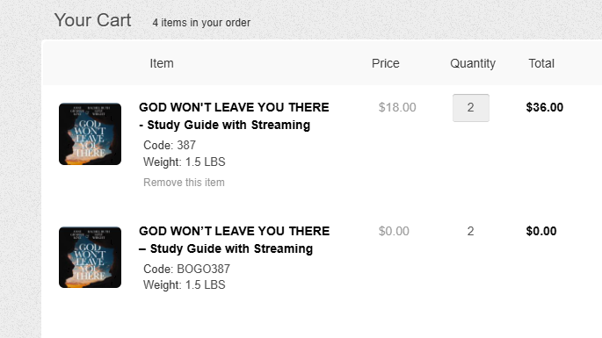

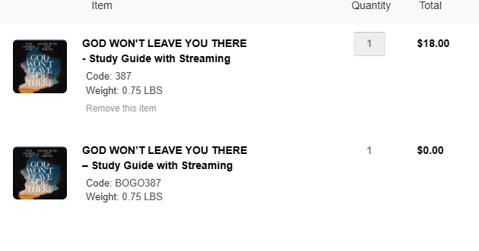

Please call our office (Phone: 919-787-6606) Monday – Friday 8am-4pm EST with any questions.

